- BANK LOAN REPORT | SUMMARY
KPI’s:
Total Loan Applications
Select COUNT(id) as Total_Loan_Applications from bank_loan_data
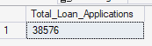
MTD Loan Application:
Select COUNT(id) as MTD_Total_Loan_Applications from bank_loan_data
where MONTH(issue_date) = 12
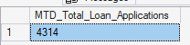
PMTD Loan Application:
Select COUNT(id) as PMTD_Total_Loan_Applications from bank_loan_data
where MONTH(issue_date) = 11
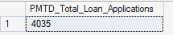

Total Funded Amount
Select SUM(loan_amount) as Total_Funded_Amount from bank_loan_data
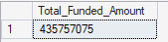
MTD Total Funded Amount
Select SUM(loan_amount) as MTD_Total_Funded_Amount from bank_loan_data
where MONTH(issue_date) = 12 and YEAR(issue_date) = 2021
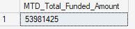
PMTD Total Funded Amount
Select SUM(loan_amount) as MTD_Total_Funded_Amount from bank_loan_data
where MONTH(issue_date) = 12 and YEAR(issue_date) = 2021
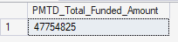
Total Amount Received
Select SUM(total_payment) as Total_Amount_Received from bank_loan_data
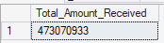
MTD Total Amount Received
Select SUM(total_payment) as MTD_Total_Amount_Received from bank_loan_data
where MONTH(issue_date) = 12 and YEAR(issue_date) = 2021
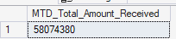
PMTD Total Amount Received
Select SUM(total_payment) as PMTD_Total_Amount_Received from bank_loan_data
where MONTH(issue_date) = 11 and YEAR(issue_date) = 2021
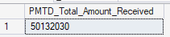

Average Interest Rate
Select AVG(int_rate) * 100 as Avg_Interest_Rate from bank_loan_data
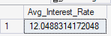
MTD Average Interest
Select AVG(int_rate) * 100 as MTD_Avg_Interest_Rate from bank_loan_data
where MONTH(issue_date) = 12 and YEAR(issue_date) = 2021
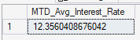
PMTD Average Interest
Select AVG(int_rate) * 100 as PMTD_Avg_Interest_Rate from bank_loan_data
where MONTH(issue_date) = 11 and YEAR(issue_date) = 2021
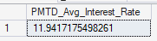

Avg DTI
Select AVG(dti) * 100 as Avg_DTI from bank_loan_data
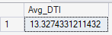
MTD Avg DTI
Select AVG(dti) * 100 as MTD_Avg_DTI from bank_loan_data
where MONTH(issue_date) = 12 and YEAR(issue_date) = 2021
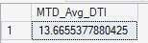
PMTD Avg DTI
Select AVG(dti) * 100 as PMTD_Avg_DTI from bank_loan_data
where MONTH(issue_date) = 11 and YEAR(issue_date) = 2021
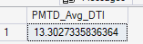
GOOD LOAN ISSUED
Good Loan Percentage
Select
(COUNT(case when loan_status = 'Fully Paid' or loan_status = 'Current' then id end) * 100)
/ COUNT(id) as Good_loan_percentage from bank_loan_data
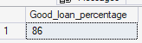
Good Loan Applications
Select COUNT(id) as Good_loan_application from bank_loan_data
where loan_status = 'Fully Paid' or loan_status = 'current'
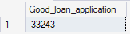
Good Loan Funded Amount
Select SUM(loan_amount) as Good_loan_funded_amount from bank_loan_data
where loan_status = 'Fully Paid' or loan_status = 'current'
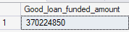
Good Loan Amount Received
Select SUM(total_payment) as Good_loan_received_amount from bank_loan_data
where loan_status = 'Fully Paid' or loan_status = 'current'
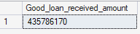

BAD LOAN ISSUED
Bad Loan Percentage
Select
(COUNT(case when loan_status = 'charged off' then id end) * 100.0)
/COUNT(id) as Bad_loan_percentage
from bank_loan_data
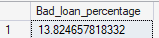
Bad Loan Applications
Select COUNT(id) as Bad_loan_application from bank_loan_data
where loan_status = 'Charged Off'
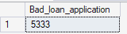
Bad Loan Funded Amount
Select SUM(loan_amount) as Bad_loan_funded_amount from bank_loan_data
where loan_status = 'Charged Off'
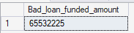
Bad Loan Amount Received
Select SUM(total_payment) as Bad_loan_received_amount from bank_loan_data
where loan_status = 'Charged Off'
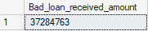

LOAN STATUS
Select
loan_status,
COUNT(id) as Total_Loan_Applications,
SUM(total_payment) as Total_Amount_Received,
SUM(loan_amount) as Total_Funded_Amount,
AVG(int_rate * 100) as Interest_Rate,
AVG(dti * 100) as DTI
from
bank_loan_data
Group By
loan_status
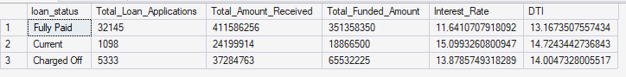

SELECT
loan_status,
SUM(total_payment) AS MTD_Total_Amount_Received,
SUM(loan_amount) AS MTD_Total_Funded_Amount
FROM bank_loan_data
WHERE MONTH(issue_date) = 12
GROUP BY loan_status
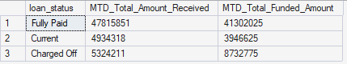

- BANK LOAN REPORT | OVERVIEW
MONTH
Select
MONTH(issue_date) as Month_Number,
DATENAME(Month, issue_date) as Month_Name,
COUNT(id) as Total_Loan_Applications,
SUM(loan_amount) as Total_Funded_Amount,
SUM(total_payment) as Total_Received_Amount
from bank_loan_data
group by MONTH(issue_date), DATENAME(month, issue_date)
order by MONTH(issue_date)
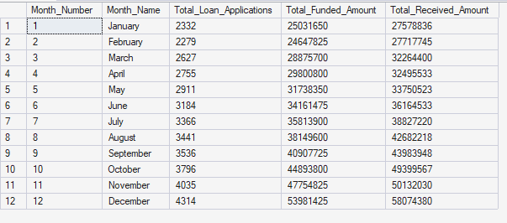

STATE
Select
address_state as state,
COUNT(id) as Total_Loan_Applications,
SUM(loan_amount) as Total_Funded_Amount,
SUM(total_payment) as Total_Received_Amount
from bank_loan_data
group by address_state
order by address_state
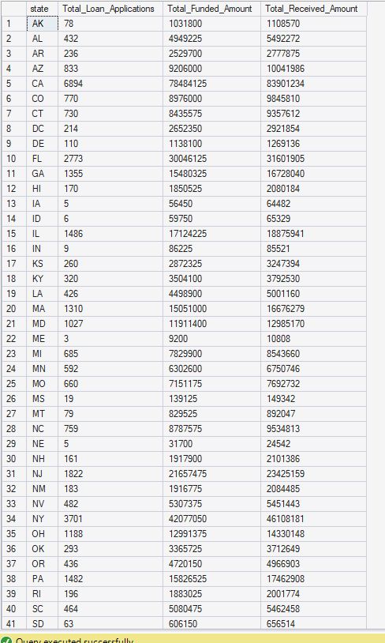

TERM
Select
term,
COUNT(id) as Total_Loan_Applications,
SUM(loan_amount) as Total_Funded_Amount,
SUM(total_payment) as Total_Received_Amount
from bank_loan_data
group by term
order by term
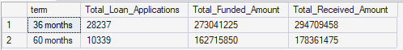
EMPLOYEE LENGTH
Select
emp_length as Employee_length,
COUNT(id) as Total_Loan_Applications,
SUM(loan_amount) as Total_Funded_Amount,
SUM(total_payment) as Total_Received_Amount
from bank_loan_data
group by emp_length
order by emp_length
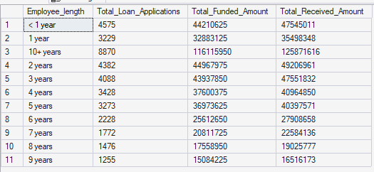

PURPOSE
Select
purpose,
COUNT(id) as Total_Loan_Applications,
SUM(loan_amount) as Total_Funded_Amount,
SUM(total_payment) as Total_Received_Amount
from bank_loan_data
group by purpose
order by COUNT(id) desc
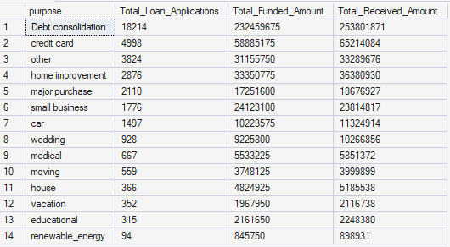
HOME OWNERSHIP
Select
home_ownership,
COUNT(id) as Total_Loan_Applications,
SUM(loan_amount) as Total_Funded_Amount,
SUM(total_payment) as Total_Received_Amount
from bank_loan_data
group by home_ownership
order by COUNT(id) desc

